Our website mainly includes login interface, welcome interface and function interface. The login interface contains two functions, login and registration, to provide users with the choice to enter the website. After successful login, the welcome screen is displayed, and then the function screen is displayed. The functional interface mainly contains robot list and exploration record. Among them, the robot list can show the existing robots and their numbers in the login account. In addition to this, users can select the robot they want to connect to and view the overall statistics of the robot's exploration record. After selecting the robot for connection, the user can enter the exploration record interface to view or modify the existing robot exploration record. We implemented most of the functionality of the website in the middle of the project. Then, at the end of the project, we improved the entire robot website, including functional improvement and page beautification.

Web Functions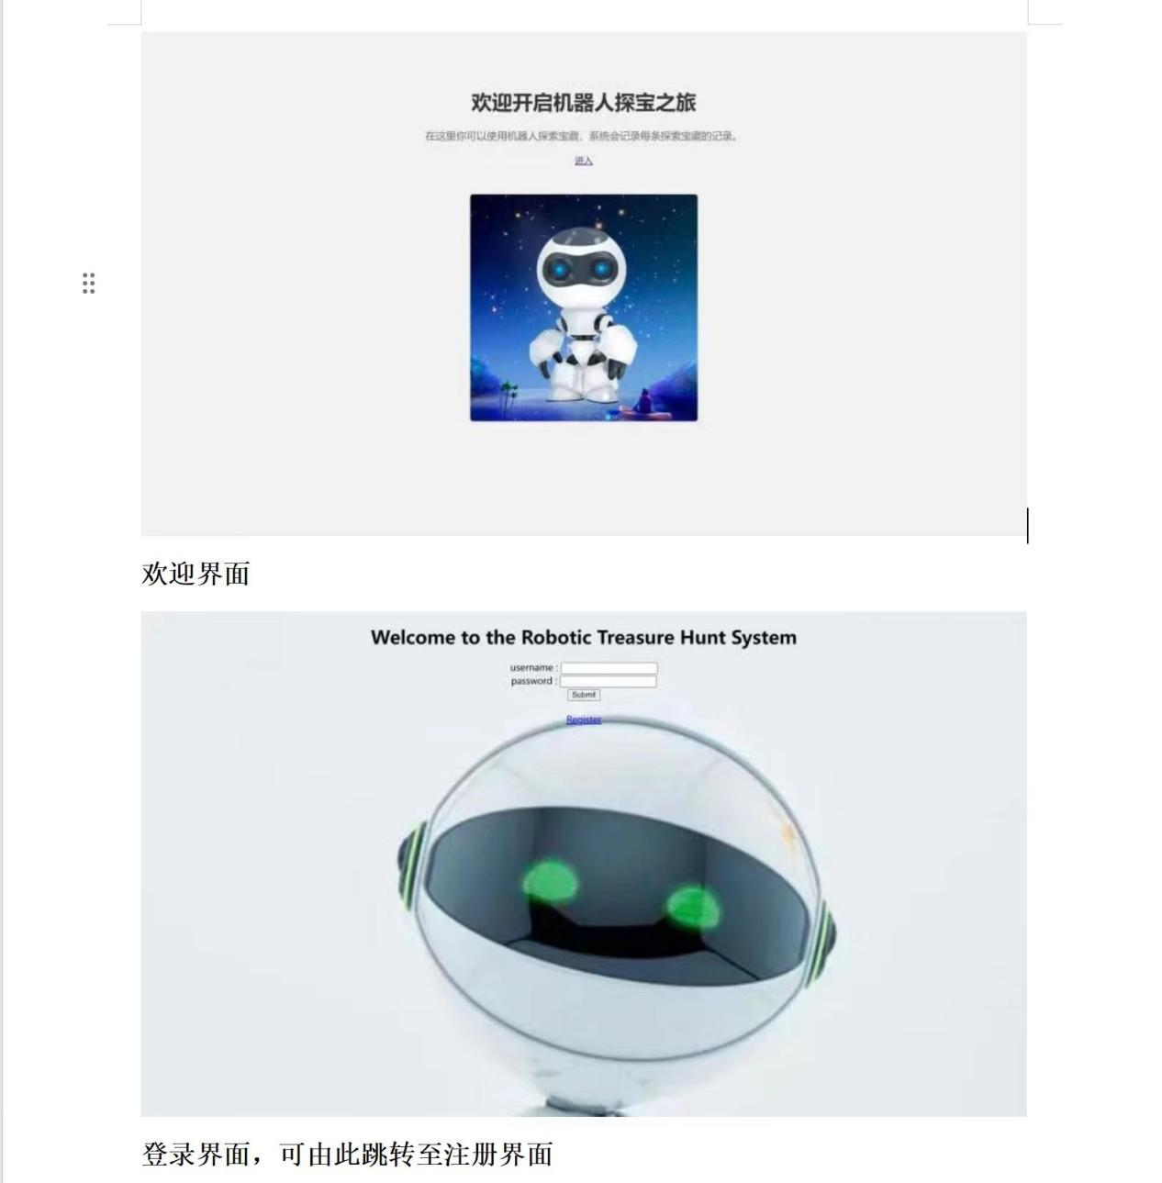

This displays the login screen, where users can login or register a new account, or jump to the "null" screen if the account doesn't exist or an incorrect account password has been entered.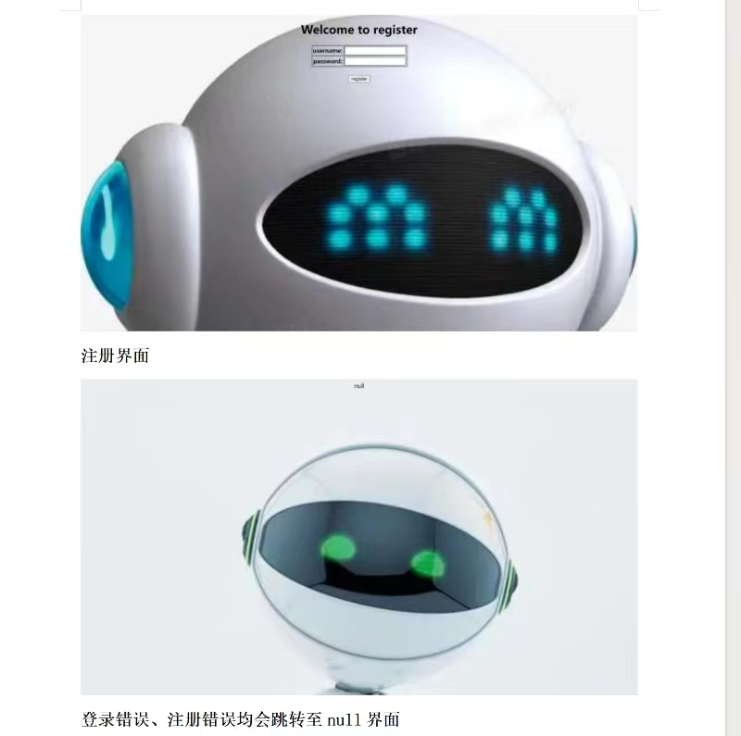

This is the registration screen where users can register a new account, or jump to the "null" screen if the registered account already exists.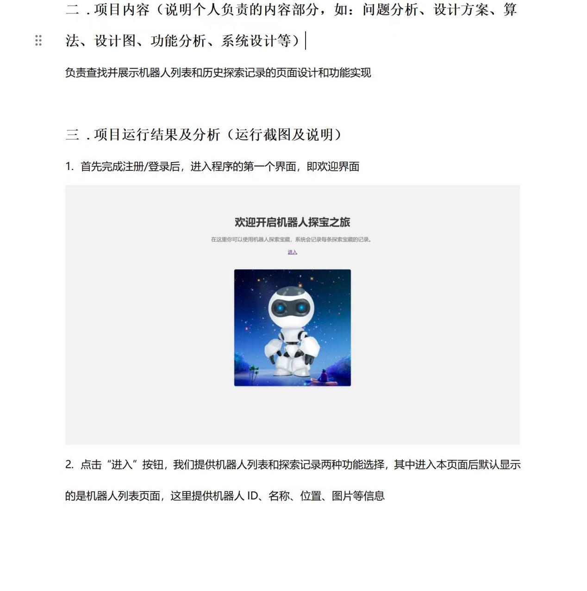

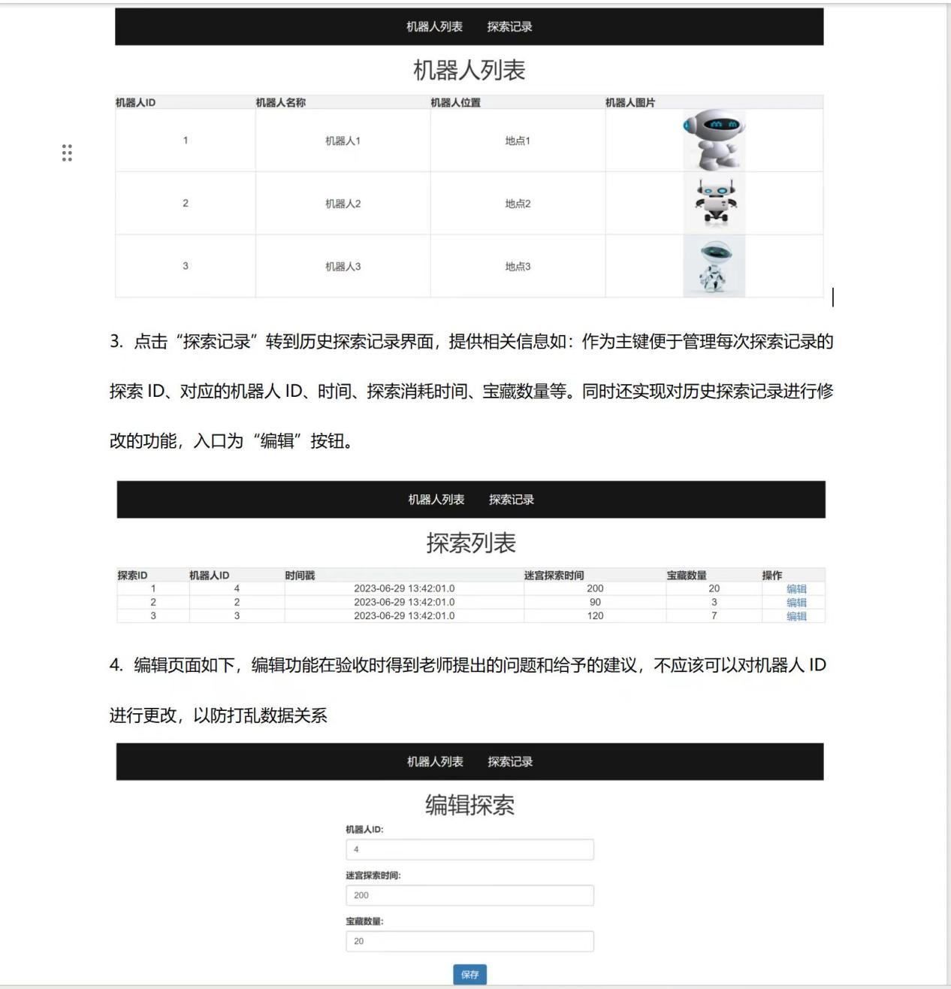

This page shows the robot data page and edit page, the robot list can view all the information of the robot, the exploration list can view the exploration records of the robot, and the edit page can make changes to the basic data of the robot and the exploration data.